REGULARISATION APPLICATION
The Building Act 1984
The Building Regulations 2010
BEDFORD BOROUGH COUNCIL
Building Control Services
Borough Hall
Cauldwell Street
Bedford.
MK42 9AP
Tel: (01234) 718081 Fax: (01234) 718083
Email: buildingcontrol@bedford.gov.uk



This form is to be filled in by the owner or the agent. If the form is unfamiliar please read the notes which follow or consult
your local Building Control office.
1
Applicant’s details (see note 1)
Name:
Address:
Postcode: Tel: email:
2
Agent’s details (if applicable)
Name:
Address:
Postcode: Tel: email:
3
Location of building to which work relates
Address: Postcode:
4

Work carried out (see note 2)
Description:
Date work carried out
5
Use of Building
If new building or extension please state proposed use:
If building is existing please state present use:
Is the building to be put, or intended to be put, to a use to which the Regulatory Reform (Fire safety)
Order 2005 applies (see note 6): No/Yes
6
Domestic Electrical Work (to be completed for all domestic applications that include electrical work)
Has a competent electrician who is registered with a Part P Self Certifying Scheme carried out the
Electrical installation? No/Yes
7

Fees (see note 3 and our Guidance Note on Fees for information).
No of dwellings/Replacement Windows:
Floor Area:
Estimated Cost:

Regularisation Fee Enclosed £

N.B. If paying the appropriate fee via the Council’s website (www.bedford.gov.uk)
Please specify the unique identifier used:
Otherwise the appropriate fee should be submitted with this notice (cheques made payable to Bedford Borough Council).

8

Statement
This notice is given in relation to the building work as described, is submitted in accordance with Regulation 18 and is accompanied by the appropriate fee.

Name: Signature: Date:

For Office Use
Name on Cheque:
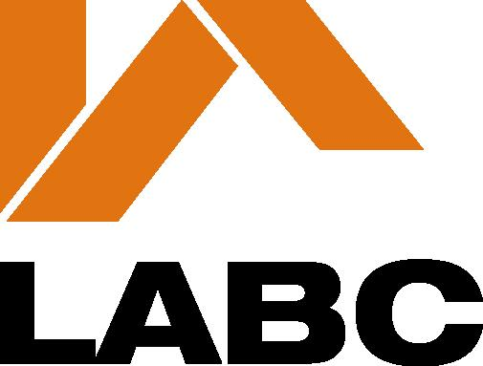
Value of Cheque: | Receipt Number:
Cheque Number: | Income Code:

Guidance Notes

1 The applicant is the person on whose behalf the work is being carried out, e.g. the building’s owner.

2 One copy of this notice should be completed and submitted with plans and particulars indicating the works carried out.

Where Part B (Fire Safety) imposes a requirement in relation to building work a further two copies of the plans should be submitted.

3 A Regularisation application must be accompanied by the appropriate fee (VAT is not payable)

When fees are based on an estimated cost of the work a written estimate of the total cost of the work shown on the plans must be provided with the application.

The appropriate fee is dependent upon the type of work carried out. Fees scales and methods of calculation are set out in the Guidance Notes on fees which is available on request.

The fee for a Regularisation application is Non-refundable

4 In accordance with Building Regulation 18 the Council may require an applicant to take such reasonable steps, including opening up the unauthorised work for inspection, making tests and taking samples as the authority think appropriate to ascertain what work, if any, is required to secure compliance with the relevant regulations.

5 These notes are for general guidance only; full particulars of a “Regularisation” request are contained in Regulation 18 of the Building Regulations (Amendment) Regulations 2010, and in respect of fees, in the Building (Local Authority Charges) Regulations 2010.

6 Premises to which the Regulatory Reform (Fire Safety) Order 2005 applies are:
- All buildings except a residential dwelling house.

7 Persons who have carried out the building work or have made a material change of use of a building are reminded that permission may also have been required under the Town & Country Planning Act.

8 Further information and advice may be obtained from Building Control at your local council.

Bedford Borough Council is registered under the Data Protection Act 1998 for the purpose of processing personal data in the performance of its legitimate business. Any information held by the Council will be processed in compliance with the principles set out in the Act.

The Council must protect the public funds it holds so any information you provide on this form the Council may be used by the Council to prevent and/or detect fraud. The information may be shared, for the same purpose, with any other organisations which handle public funds.

Further information relating to the Data Protection Act can be sent to you on request.

If you have concerns about the processing of your personal data by the Council you may contact the Head of Building Control or the Data Protection Officer at Borough Hall Cauldwell Street Bedford MK42 9AP or the Information Commissioner’s Office at Wycliffe House Water Lane Wilmslow Cheshire SK9 5AF.

