FULL PLANS

SUBMISSION
The Building Act 1984
The Building Regulations 2010

BEDFORD BOROUGH COUNCIL
Building Control Services
Borough Hall
Cauldwell Street
Bedford.
MK42 9AP
Te: (01234) 718081 Fax: (01234) 718083
Email: buildingcontrol@bedford.gov.uk

This form is to be filled in by the owner or the agent. If the form is unfamiliar please read the notes which follow or consult
your local Building Control office.
1
Applicant’s details (see note 1)
Name:
Address:
Postcode: Tel: email:

Agent’s details (if applicable)
2
Name:
Address:
Postcode: Tel: email:
3
Location of building to which work relates
Address: Postcode
4
Proposed Work
Description:
Is the proposed work or any part of it subject to Partnering or a current LANTAC approval? (see note 4) No/Yes
5
Use of building
If new building or extension please state proposed use:
If building is existing please state present use:
Is the building to be put, or intended to be put, to a use to which the Regulatory Reform (Fire Safety)
Order 2005 applies? (see note 5) No/Yes
6
Domestic Electrical Work (to be completed for all domestic applications that include electrical work)
Will a competent electrician who is registered with a Part P Self Certifying Scheme carry out the
electrical installation? No/Yes
7
Fees (see note 3 and our Guidance Note of Fees for information).
No of dwellings/Replacement windows
Floor area
Estimated Cost
Plan Fee Enclosed £
N.B. If paying the appropriate fee via the Council’s website (www.bedford.gov.uk)
Please specify the unique identifier used:
Otherwise the appropriate fee should be submitted with this notice (cheques made payable to Bedford Borough Council).
8
Extension of Time and Conditions (see note 6)
Do you agree to an extension of time? No/Yes
Do you consent to the plans being passed subject to conditions where appropriate? No/Yes
9

Statement
This notice is given in relation to the building work as described, is submitted in accordance with Regulation 12(2) (b) and is accompanied by the appropriate fee. I understand that further fees will normally be payable following the first inspection by the local authority.

Name: Signature: Date:

For Office Use
Name on Cheque:
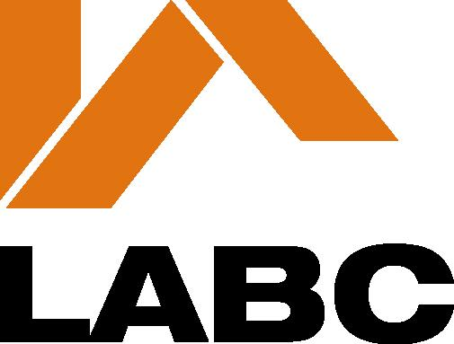
Value of Cheque: | Receipt Number:
Cheque Number: | Income Code:

Guidance Notes

1 The applicant is the person on whose behalf the work is being carried out, eg the building’s owner.

2 One copy of this notice should be completed and submitted with plans and particulars in duplicate in accordance with the provisions of Building Regulation 14.

Subject to certain exceptions where Part B (Fire Safety) imposes a requirement in relation to proposed building work, two further copies of plans which demonstrate compliance with the requirements should be deposited.

3 Subject to certain exceptions a Full Plans Submission attracts fees payable by the person by whom or on whose behalf the work is to be carried out. Most fees are payable in two stages. The first fee must accompany the deposit of plans (Plan charge) and the second fee is payable after the first site inspection (Inspection charge) of work in progress. The second fee is a single payment in respect of the relevant work to cover all site visits and consultations which may be necessary until it is satisfactorily completed.

When fees are based on estimated cost of the work, an estimate of the total cost of the work shown on the plans must be provided.

The appropriate fee is dependent upon the type of work proposed. Fee scales and methods of calculation are set out in the Guidance Notes on fees which is available on request.

4 LABC Services provides a Partner Authority Scheme and also National Type Approval for a range of building types, building systems and major building elements where they are used repeatedly.

If this proposal is to use the Partnering scheme please answer YES and provide further details, including name of the Partner Authority, in section 4. If the work proposed or any part of it is subject to a LANTAC approvals please answer YES and enclose a copy of the appropriate current certificate(s). If there is any variation in this proposal from that shown on the LANTAC type approval plans attention should be drawn to it in a covering letter. Further information on LANTAC schemes is available from your local Building Control Service, or LABC Services.

5 Premises to which the Regulatory Reform (Fire Safety) Order 2005 applies are:
- All buildings accept a residential dwelling house.

6 Section 16 of the Building Act 1984 provides for the passing of plans subject to conditions. The conditions may specify modifications to the deposited plans and/or that further plans shall be deposited.

7 These notes are for general guidance only; full particulars regarding the deposit of plans are contained in Regulation 14 of the Building Regulations 2010 and, in respect of fees, in the Building (Local Authority Charges) Regulations 2010.

8 Persons proposing to carry out building work or make a material change of use of a building are reminded that permission may be required under the Town and Country Planning Acts.

9 Further information and advice may be obtained from Building Control at your Local Authority.

10 This application shall cease to have effect from three years after it is given to the Local authority unless the work has been commenced before the expiry of that period and due notice has been given to the Local Authority.

Bedford Borough Council is registered under the Data Protection Act 1998 for the purpose of processing personal data in the performance of its legitimate business. Any information held by the Council will be processed in compliance with the principles set out in the Act.

The Council must protect the public funds it holds so any information you provide on this form the Council may be used by the Council to prevent and/or detect fraud. The information may be shared, for the same purpose, with any other organisations which handle public funds.

Further information relating to the Data Protection Act can be sent to you on request.

If you have concerns about the processing of your personal data by the Council you may contact the Head of Building Control or the Data Protection Officer at Borough Hall Cauldwell Street Bedford MK42 9AP or the Information Commissioner’s Office at Wycliffe House Water Lane Wilmslow Cheshire SK9 5AF.

