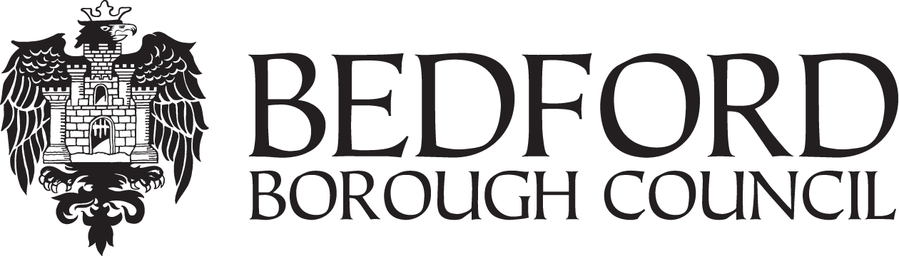

PROCUREMENT STRATEGY
___________________________________________________________________________

GUIDE TO SUSTAINABLE PROCUREMENT
GREEN PROCUREMENT GUIDELINES

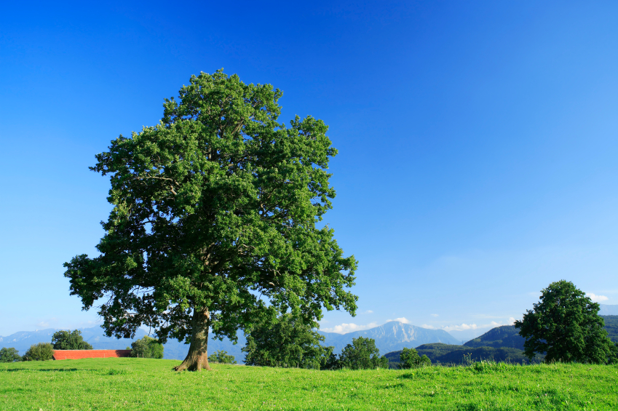
INDEX

- BEDFORD BOROUGH COUNCIL’S GREEN PROCUREMENT GUIDELINES

Page

General Principles 3

Energy 3

Waste & Recycling 3

Water 3-4

Construction & Maintenance 4

Resources & Biodiversity 4

Transport and Travel 4

- PUTTING THE GREEN PROCUREMENT RULES INTO PRACTICE

Identifying Need 5

Advertisements and Pre-Qualifying Questionnaires (PQQs) 5

Tenders 6

Managing Contracts 6

The Legal Situation 7

Whole-life Costing and Investing 7

- ADVICE & SUPPORT 8

APPENDIX 1: BACKGROUND TO THE GREEN PROCUREMENT RULES

Vision and Purpose 9

Why do we need Green Procurement Rules? 9

What makes a Product Green? 10

What about the Cost? 10

Key Environmental Issues 10-11

- BEDFORD’S GREEN PROCUREMENT RULES

In order to help us to avoid damaging the environment and to help to find solutions to the environmental problems described in Appendix 1, the Council has adopted the following guidelines, which must be adhered to when decisions to buy or award a contract are made:

General Principles

- Our procurement should be aligned with our ‘One Bedford vision, our Sustainable Communities Strategy and our Sustainability Action Plan;

- We prefer to buy products and services from organisations with a fully certified Environmental Management System (EMS) and an established environmental policy.

Energy

- When we buy energy direct from the supplier, we prefer green electricity sources (renewable energy sources such as wind, wave, tidal and solar power and the most efficient traditional combined heat and power) and we avoid nuclear power;

- All electricity and gas supply accounts must be on the Council’s supply contracts which are managed by the Council’s Bedford Design Group (BDG). BDG must be informed of any changes in service provision/developments that will/could affect the energy consumption of a property at the earliest possible stage;

- We prefer products and services that are energy-efficient compared to alternatives; whole life costing should be used to ensure equipment choices are based on the life cost of the equipment and not just purchase price;

- Our guiding principle will be our target to reduce CO2 emissions and have signed up to the 10:10 CO2 saving initiative.

Waste & Recycling

- We prefer to avoid using products that cannot be reused, recycled or composted;

- We will send items we don’t want, but that can be used, to local materials and equipment exchange services.

Water

- We prefer products and services that are water–efficient compared to alternatives;

- We do not buy bottled water;

- When we refurbish buildings or develop new ones, we must consider water-efficiency measures e.g. reusing water (for example, rainwater) to reduce how much fresh water from the mains we use.

Construction & Maintenance

- When we refurbish buildings or build new ones, we will follow ‘Supplementary Planning Guidance’ in terms of green construction as far as possible and seek advice from relevant experts (e.g. the Sustainability Officer – Planning or BDG);

- We will endeavour to design buildings to the highest possible sustainability standards meeting, and where possible, exceeding the requirements set by government;

- Extra up-front costs for the most environmentally friendly options must be reviewed with a whole life costing approach before being rejected, and relevant guidance taken into account which may require green expenditure to be prioritised.

Resources & Biodiversity

- We will consider the impact on biodiversity when we buy products or services, and aim to minimise damage to habitats and support their development;

- When we buy timber and wood-derived products (including stationery), we will only buy legal and preferably sustainable timber – this means that the wood must come from government approved certification schemes, preferably the Forest Stewardship Council (FSC);

- We prefer products made from recycled materials, and to use reclaimed materials;

- We will not use chlorofluorocarbons (CFCs), hydrochlorofluorocarbons (HCFCs), persistent organic pollutants (POPs), and chemicals that the European Union classifies as substances of very high concern, or other harmful chemicals.

- We will avoid using ‘volatile organic chemicals’ (‘VOCs’ – which can be present in goods such as paint and cleaning substances), formaldehyde and harmful pesticides as far as possible, and will use artificial fertilisers as little as possible;

- We will avoid genetically modified products when we buy food or award contracts to catering services.

Transport and travel

- We prefer options that reduce the need for products to be transported;

- We prefer our contractors to support green travel arrangements.

- PUTTING THE GREEN PROCUREMENT RULES INTO PRACTICE

Our green procurement guidelines are based on the following principles:

- Banning products that damage the environment when a reasonable alternative is available;

- Promoting products that damage the environment the least;

- Taking into account whole life costs such as energy, maintenance and end of life disposal costs when we consider tenders;

- Understanding that buying environmentally friendly goods and services is part of a process of continuous improvement.

Identifying Need

We usually buy the same things we have bought in the past. To practice green procurement, we need to ask if we need to continue buying the same things. We will follow these principles:

- Think again about what to buy – do we need this? Do we need this exact product or level of service?

- Don’t buy anything that contains harmful substances;

- Consider how much energy the product uses;

- Reduce what we buy (for example, order similar goods from the same supplier);

- Consider transport costs (for example, choose local suppliers where we can);

- Reduce and Reuse (for example, use returnable packaging);

- Recycle (for example, buy recycled goods);

- Dispose of products responsibly.

Advertisements and Pre-Qualifying Questionnaires (PQQs)

We want suppliers to compete to give us the best possible value for money and maximum innovation in terms of the environmental impacts of goods and services. This means that we need to make our environmental requirements clear right from the start of the procurement process, i.e. in advertisements where relevant and in PQQs. In PQQs, we can include environmental ‘show-stopper’ questions for contracts where the environmental impact is significant enough. The Environmental Services Team in the Directorate of Environment & Sustainable Communities can advise on which contracts this applies to and also suitable criteria/wording.

Tenders

Environmental requirements must also be set out at the Invitation to Tender (ITT) stage. There is scope for more detail here than at PQQ. The greater the environmental impact of your procurement, the more heavily you should weight your sustainability criteria e.g. low environmental impact procurement may only be 5% of the quality aspect of the award criteria, and high impact procurements, 20%. The Environmental Services Team can help you to identify suitable environmental criteria, as well as assessing how well these are met by potential suppliers in their submissions.

The environmental impact assessment will help you assess the impact your contract will have on the environment, and so indicate how much of your quality consideration should be based on environmental concerns. We need to consider the costs over the life of the goods or services, including environmental costs such as how much energy a product uses and the cost of selling it on or throwing it away. This gives us savings in, for example, running and maintenance costs, which will reduce any increase in buy-in costs.

Managing Contracts

By linking managing and reviewing contracts to achieving targets, we can make sure that our suppliers take account of the environment. Using improvement targets and key performance indicators (‘KPIs’ – standards we can measure our suppliers’ performance against), we can cover the whole range of environmental impacts, from using raw materials, production, transportation and use, to options for managing products at the end of their life. Joint improvement targets can involve:

- Ensuring that the contractor/supplier has an environmental management system or environmental policy;

- Reducing the contract’s carbon footprint through energy efficiency and other measures;

- Increasing the amount of waste recycled;

- Reducing water consumption; and

- Increasing the amount of locally purchased goods and services.

An example of a KPI you could include: Company will be able to evidence that 100% of wood purchased has come from a sustainable source. Again, the Environmental Services Team can help with the development of suitable environmental KPIs.

The Legal Situation

The Official Journal of the European Union caveat has provision for us to buy green:

‘Public Contracts Regulations 2006’

38.
- A contracting authority may include in the contract documents relating to a public works contract or to a public services contract information as to where a contractor or services provider may obtain information about the obligations relating to taxes, environmental protection, employment protection and working conditions which will apply to:

- the work or works to be carried out under a public works contract; or

- the services to be provided under a public services contract.

- A contracting authority which provides the information referred to in paragraph (1) shall request contractors or services providers to indicate that they have taken account of the obligations relating to those employment protection provisions and those working conditions in preparing their tender or in negotiating the contract.’

We already have to follow a wide range of European Union (EU) and national laws relevant to green procurement. This is only likely to increase (e.g. new EU laws on using chemicals are being agreed). The green procurement rules will be updated accordingly.

Whole-life Costing and Investing

Whole-life costing (also known as life-cycle costing) is the process of considering the basic cost of buying a product or service, and all the costs over its lifetime. This means considering how much it will cost to use and maintain (such as how much energy it uses), as well as the cost of getting rid of it. Very often, when we compare the more environmentally friendly option with the more environmentally damaging one, the whole-life costs of the first option will balance out any saving we make on the basic price of buying the second option. However, it may also mean being prepared to pay slightly more to get the product that will eventually cost us less over its lifetime and be better for the environment – in other words, investing to save.

Bedford encourages use of whole-life costing in procurement decisions. The Corporate Procurement Team and the Environmental Services Team can provide help with this.

- ADVICE & SUPPORT

Advice and support is available from:

- Environmental Sustainability – the responsibility for green procurement falls within the remit of the Environmental Services Team within the Directorate of Environment & Sustainable Communities. Please contact the sustainabilityteam@bedford.gov.uk

- Corporate Carbon & Energy Manager – In relation to other corporate energy matters and in particular for the councils overall energy usage and management responsibility against the CRC Energy Efficiency Scheme please contact James Sherman on james.shearman@bedford.gov.uk

- The Procurement Team at central.procurement@bedford.gov.uk

- Bedford Design Group in relation to energy matters involving the councils building portfolio.

APPENDIX 1

BACKGROUND TO THE GREEN PROCUREMENT RULES

Vision and Purpose:

We are committed to making Bedford a greener place to live and work, now and in the future. We plan to achieve this by:

- Taking practical action to reduce the effect our activities have on the environment;

- Sourcing green products;

- Improving the quality of the local environment; and

- Encouraging the people of Bedford to live and work in ways that reduce the Borough's effect on worldwide environmental problems, to improve the environment now and protect it for the future.

Why do we need Green Procurement Guidelines?

Buying products or contracting for services can have significant environmental impacts, and so procurement is a critical part of achieving our vision. The purpose of these rules is to minimise the negative and maximise the positive environmental impacts of buying decisions. The range of products and services we procure provides a substantial opportunity to influence our supply chain to both reduce their negative and increase their positive impacts on our environment. Buying environmentally friendly goods and services also reduces our exposure to environmental risk.

Although we have to balance the benefits of buying environmentally friendly goods and services with costs and other business needs, we cannot ignore the environment when we make purchasing decision. Each officer advised by the Strategic Procurement Team will be encouraged to ensure that sustainability is part of the procurement process and suite of supporting guidance and templates. For example, officers should complete an environmental impact assessment and to include sustainability as part of their award criteria.

Green procurement involves integrating environmental considerations into all stages of the purchasing process: from avoiding unnecessary purchases and identifying greener products to the specifications you use for contracts and whole life costing. Quality is the priority: green products are fit for purpose and can be cost comparable.

Green procurement is not limited to buying recycled paper but stretches across business activity including construction, furniture, IT equipment and transport. By making informed choices about the products we buy, we can make a real difference to the environment and improve our resource efficiency.

What makes a Product Green?

Green products are made or operate in a way that:

- Uses fewer natural resources;
- Contains fewer hazardous or toxic materials;
- Has a longer life span;
- Consumes less energy or water in production or use;
- Can be reused or recycled on disposal;
- Generates less waste, for example: be made from recycled materials, use less packaging or be recycled by the supplier.

What about the Cost?

The price of green products is often perceived as a barrier to green purchasing. Many greener products are of equal or lower price that their non-green equivalents. Even where the initial price of greener products is higher, lower costs of use and disposal may still make it the best value choice overall. The UK government is committed to sustainable consumption and production, and advocates use of government purchasing power to stimulate demand for greener products – which in turn should reduce prices.

The best ways to control costs are specifications reflecting performance needs, comparison shopping, bulk purchase, competitive bid processes and whole life costing (initial purchase cost + cost in use + disposal costs). Furthermore, green procurement usually goes hand in hand with waste minimisation, meaning you use less in the first place.

Key Environmental Issues

The following section gives a brief overview of the main environmental issues.

- Climate change: Bedford’s strategy for tackling climate change is a mixture of ‘mitigation’ and ‘adaptation’ measures. Mitigation measures are those which minimise the level of carbon dioxide and other greenhouse gas emissions so that we slow the rate of climate change. An example would be buying the most energy efficient product possible or ensuring a service provider manages their energy use well and/or uses renewable energy. Adaptation measures are those which help us to deal with the effects of climate change which are now inevitable. An example would be choosing materials for a construction project that will better withstand the more extreme weather conditions that climate change brings;

- Waste: We can reduce waste by following the principle of ‘reduce, reuse and recycle’. In terms of procurement this means:

- ensuring that you only order products/services that you really need (reuse existing resources wherever possible);

- ensuring that your suppliers have strong waste and recycling practices; and

- buying products with recycled content wherever possible.

- Pollution: We can help to tackle this problem by not using products containing:

- persistent organic pollutants (POPs), for example, pollutants created when waste containing chlorine is burned;

- chemicals that the EU classify as substances of very high concern;

- polyvinylchloride (PVC), which can be found in plastics and textiles;

- chlorofluorocarbons (CFCs), which can be found in old fridges; and

- hydrofluorocarbons (HFCs), which were developed to replace CFCs in fridges but are still very harmful.

- Biodiversity: Plants and wildlife are being destroyed by things such as chemical, pesticide or radioactive pollution, or genetically modified organisms (GMOs). Habitats are also threatened and can be lost through for example construction, deforestation, mining, and certain intensive methods of farming. We can tackle this by:

- taking some of the actions described above to avoid using harmful substances;

- buying only sustainable timber and related products e.g. hoardings (see Sustainable Timber Policy and Guidance for further detail);

- choosing food that is non-GMO or grown organically; and

- seeking to engage suppliers who respect biodiversity.

- Water: Water is set to become an increasingly important environmental issue as climate change leads to more extreme weather conditions such as flooding and water shortages (especially in the South East of England). Therefore we should buy products and services that minimise water use where possible and are ‘future-proofed’ against more extreme weather e.g. sustainable urban drainage systems (SUDS).

