
BEDFORD BOROUGH COUNCIL
CCTV CODE OF PRACTICE

Doc Ref: | CCTV COP
Version / Revision: | v1/r1
Issue Date: | November 2019
Review Date: | November 2021
Author: | John McKinney

Bedford Borough Council - CCTV Code Of Practice
Section Details Page
1 Introduction 3-4
2 Agreed Principles 4-5
3 System Objectives 5-6
4 Operations – Monitoring 6-7
5 Operations - Recording 7-8
6 Access – Operational 8
7 Regulation Of Investigatory Powers Act 2000 9-10
8 Access – No Operational or ‘PR’ Visits 10
9 Emergency Closure 11
10 Alternative Control Centres 12
11 Release Of CCTV Data – Police Or Other Investigators 12
12 Release Of Imagery To The Public (Subject Access) 13
13 Release Of Imagery To The Public Or Others Under 13
Section 37 Data Protection Act and Data Protection Bill 13
14 Freedom of Information (FOI) Requests 13
15 Emergency Planning & Civil Contingency 14
16 Third Party Systems 14
17 Body Worn Systems (BWV) 14
LIST OF ANNEXES
A. Signage 15
B. SOPs and Assignment Instructions 16
C. Relevant Acts, Regulations and COPs Governing 17
D. Diagram of responsibilities 18
E. Broadlands Company details 19
F. Information sharing agreements 20
G Access List 21
H Subject Access Procedure (SAR) 22
I Third Party Sites 23
INTRODUCTION

This Code of Practice is the current version. A Code of Practice is defined as "Principles, values, standards, or rules of behaviour that guide the decisions, procedures and systems of an organisation in a way that contributes to the welfare of its key stakeholders, and respects the rights of all constituents affected by its operations."

Bedford Borough Council (BBC) has installed a CCTV System throughout Bedford town centre and other locations within the borough. The core of the system are cameras owned and maintained by Bedford Borough Council, with some cameras in the ownership of Parish Councils or individual Wards within the borough. These third party cameras have been incorporated into the ‘CCTV system’ in order that they can be operated and monitored on their behalf, from within the BBC CCTV control centre. The core BBC owned system currently comprises circa 700 cameras, although this is subject to change by expansion or reduction subject to necessary circumstances.

BBC also deploys and operates a number of networked deployable ASB hot spot cameras from the same control centre, and for the purposes of this code they are considered part of the CCTV system. This inventory includes portable stand-alone cameras, used when it is considered the best way to achieve a particular objective.

There are a number of Automatic Number Plate Recognition (ANPR) cameras at strategic locations throughout the borough. These are owned and operated by Bedfordshire Police. While BBC CCTV receives ANPR data from the police via a dedicated link, it does not own or maintain its own ANPR equipment within the BBC control room.

Other departments in the council e.g. Parking Services may deploy and use cameras capable of obtaining and storing ANPR data for the purposes of the management and charging regimes in Council owned car parks. Some of the system CCTV cameras are in a position or may have resolution and discrimination that will capture vehicle registrations from time to time, but it is not the purpose of the camera. Any vehicle registrations are considered personal data under the DPA and GDPR and will be treated accordingly.

All cameras on the system are ‘overt’ and not covert. Signage will be displayed at key points around the perimeter of the system warning that members of the public are entering a zone covered by CCTV and giving the following details

- The Data controller
- The contact number of those charged with the day to day operation of the system
- Any other information
An example of signage is at Annex A – Page 15

Notwithstanding the overt and open nature of the cameras in the system, it is possible and probable that on occasion the need will arise for the police or council officers to use the cameras in operations requiring directed or covert monitoring and which falls under the auspices of the Regulation of Investigatory Powers Act (RIPA). Each request is assessed by the CCTV management on a case by case basis to ensure it meets the necessary criteria and that the correct RIPA paperwork is submitted. For rules and procedures of surveillance using RIPA see section 7 sub sections 1-9 (pages 9-10)

In addition to the core CCTV system, BBC monitors networked third party cameras via internet connectivity. These systems cover local or other businesses and do not form part of BBC’s Public Space CCTV system, however the principles herein apply equally to the use of those systems, monitored by BBC operators and the same guidelines and will be applied.

Since the initial commissioning of the system as a CCTV control room, the Control room itself has evolved into a multi-functional control room with emergency planning, Highways, third party fire response and other Out Of Hours (OOH) roles being operated from within it.

The conditions and responsibilities applicable to the service provided to these third parties are contained under separate Service Level Agreements.

AGREED PRINCIPLES

The code of practice has been agreed with the police and forms the basis for the operation of the BBC CCTV system by the staff involved in operating the system be they ‘in house’ managers or contracted staff

The code of practice should be read in conjunction with the operational standard operating procedures (SOPs) for the day to day running of the system. These documents are listed at Annex B – Page 16. All these documents are available to read in the CCTV Control Room

This code of practice has been written to comply within the existing legislation, regulations and CoP’s including

- The Data Protection Act 1998, GDPR and Data Protection Bill 2017
- Human Rights Act
- Protection of Freedoms Act
- ICO Code of Practice
- Camera Commissioners Code of Practice
- Regulation of Investigatory Powers Act
- Crime & Disorder Act
For details of the provisions of these acts see Annex C – Page 17

The Data Controller for the system is the Chief Executive of BBC. The day to

day management of the system is via the Community Safety Team, part of the Regulatory Services & Culture Group. A diagram of responsibilities is at Annex D – Page 18.

SYSTEM OBJECTIVES

The objectives of the system are to be fulfilled under the provisions laid out in the GDPR Article 6(1)(e) in that “processing is necessary for the performance of a task carried out in the public interest or in the exercise of official authority vested in the controller”

The objectives covered under this article include:

To detect and deter crime by providing oversight and monitoring of Bedford town centre, its shopping areas, car parks and other locations where members of the public may frequent and where there is an actual or perceived fear of crime.

To provide an effective system, for the identification and arrest of offenders.

To assist the courts in criminal and civil actions by providing evidence in a non-partisan, neutral, professional manner and in accordance with the provisions of the DPA and/or GDPR.

To provide a management tool for effective regulation, of the environment.

To promote and improve the public’s sense of wellbeing and safety, in the town centre and surrounding areas.

- To perform any roles that utilise fully the control rooms capability of a 24/7/365 day service. Installation of deployable cameras, and offer services that help recover the costs of its core services.

STAFFING

The BBC CCTV control room is staffed and accessed by fully trained personal supplied under contract. At present the staff are provided by BROADLANDS ltd. Company details are at Annex E – Page 19. The contractor is to ensure that the staff are:

- Trained by an accredited external organisation prior to taking up post.
- Cleared to the relevant standard (DBS and SIA) and this clearance is to be kept under review as stipulated by regulations.
- Trained internally on the systems, geographical areas and local priorities.
- The contract stipulates two persons to be on duty 24/7/365 unless agreed with the CCTV Officer or other responsible council officers. The contractor maintains procedures to ensure that the control is fully manned at all times.
- The presence of a supervisory grade, either the Broadlands CCTV manager or his deputy will form part of the shift for the Council’s core working hours for liaison purposes.

The contractors staffing arrangements must take account of the Display Screen Equipment (DSE) regulations with regards to regular, checks of eyesight and equipment.

Staffing arrangements should allow for break time as allowed under the DSE.

The contractor provides and maintains a set of simple, clear concise Standard Operating Procedures (SOP) or Assignment Instructions (AI) as detailed in Annex B to cover all aspects of the operation of the control room as agreed by the BBC CCTV Officer. The CCTV officer can make alterations to these with the agreement of the contractor.

The contractor will ensure that the operators are correctly dressed as laid out in the original tender and their own procedures.

The CCTV Officer will hold regular meetings with the contractor to ensure a good working relationship is maintained and any problems are addressed. Both sides will ensure that any such problems are properly documented.

BBC will not overburden the current staff and their core role with additional duties, if such duties have not been ergonomically assessed and costed. Where there is an affirmed need for additional duties, the contracted company will ensure additional staffing is procured commensurate with any new duties and BBC will if necessary adjust payments accordingly.

OPERATIONS – MONITORING

In total BBC CCTV monitors circa 700 CCTV Council and third party cameras (as at November 2019). The Council cameras are located in the streets, at road junctions, in multi-storey and other car parks, in pedestrian areas and in shopping centres. Many of the other cameras are ‘third party cameras’ owned by local and remote businesses.

Most BBC cameras are ‘pan, tilt and zoom’ (PTZ) cameras but many are static. In any event most will be left in the ‘monitoring’ status as described in Home Office Guidelines.

Notwithstanding the situation described in para 5.2 below, BBC CCTV operators are authorized to use the cameras, when justified in doing so, to use any camera up to HOSDB identification standard i.e. to acquire close up sufficient to identify an individual. The type of justification will include intelligence from police control rooms or any other trusted source. All such intelligence will be logged in the control room diary/Civica APP as appropriate.

Operators can also refuse to heed such requests if they think the monitoring is excessive, unjustified or based on out of date or incorrect intelligence. Operators must remember that failure to show due diligence when carrying out requests to monitor can result in actions against them.

Operators can transfer the images from designated ‘spot’ monitors to the control room of Bedfordshire police. This is subject to the data sharing agreement shown at Annex F – Page 20.

Bedfordshire Police has a capability for C³ of the core BT based fibre camera system. This capability is currently deactivated but could be re-activated if required, e.g.in the event of closure of the main BBC CCTV centre or other emergency or a Silver/Gold level response.

OPERATIONS - RECORDING

The daily routine and operational procedures are detailed in the control room SOPs or AIs. These are listed in Annex B. The control room will be staffed by two persons as per para 3.3a-e with one person present in the control room at all times e.g. if for any reason the other operator has to leave temporarily for meal or comfort breaks. Unless agreed by the manager both operators are to be present in the control room/rest room/kitchen or stores area and are not to leave the building unless relieved.

Recording – All cameras in the system are set to record 24/7/365. The Data Protection Act (DPA) the GDPR and Information Commissioners Officer (ICO) recommends that data is not kept for longer than is necessary. Most CCTV rooms nationally have opted for the retention of the routine recordings for a calendar month, as most criminal or other incident activity will have come to attention within that time.

Due to the nature of the current technology, storage requirements may fluctuate depending on breakdowns, manual switching of feeds, the compression techniques used and the amount of activity at a given camera. When this happens manual deletion will be performed as per para 5.4.below. Records will be kept of any incidents and the reasons for them. The Council is not responsible for any failure of the system to record the full calendar month

Retention of data beyond the target retention period, as described above, will be subject to review and manual deletion implemented should automatic over-recording not occur or a longer period is deemed operationally necessary as per para 5.5 below. The contract Manager or his deputy will be responsible for regular review and management of the target retention scheme.

If an incident occurs that is likely to be subject to a request for data e.g. road traffic accident, and experience shows that there is a significant lead time prior to any request for data to be made, the Control Room manager may authorise retention of this footage for a period beyond the target retention period. He will regularly review this data and delete after a reasonable additional retention period.

All requests for data to be used as evidence will be considered on a case by case basis. There is no automatic right for the police or other officials to obtain evidence.

All requests will be in writing, following the Request For Release Of CCTV Footage Process and associated appendices. If authorized, material will only be dispatched by Royal Mail Tracked Special Delivery at the expense of the addressee or as agreed. No evidence will be sent through the internal or external mail unless authorized by the manager. Such material will be risk assessed as to the consequences of loss.

ACCESS - OPERATIONAL

The CCTV room is a restricted area due to the large amount of personal and incident data being collected, the sensitive nature of some of the operations conducted there and for the security of the staff performing the work.

The Police while key partners are not exempt from the need to arrange visits in advance unless under the circumstances in 6.3c below

Access is strictly controlled. The expected procedure will be as follows:

- The use of an access control list. The current list is shown at Annex G - Page 21.

- Prior arrangement and agreement in writing of the CCTV Officer or control room manager. Initial details may be arranged over the telephone but this must be confirmed in writing.

- Under certain circumstances e.g. emergency police operations then access will be granted without written agreement but the visitors log and operations will be completed giving reasons why.

- All visitors will sign into a visitors log and be entered into the daily log by the duty operators.

- The granting of access is subject to certain conditions including the requirement to assent to limited searches of their persons or any articles they may carry about them.

RIPA

Controllers shall have due regard to the privacy of the individual and shall be sensitive to the privacy of people living and working in the town centre and other public open space areas.

Private residences may come into view only as part of a wide angle or long shot or as a camera is panning past them. Consideration should be given to the digital masking of private and business windows in regular view and particular consideration given to specific requests regarding individual’s privacy.

The controller may allow a private residence to remain in view at a level that allows the identification only when that controller has significant justification for doing so.

Directed observation of individuals should only be undertaken for good reason and for purposes and key objectives as set out in this Code of Practice.

Directed observation/surveillance must be carried out in accordance with the Regulation of Investigatory Powers Act 2000 (RIPA).

A RIPA authorisation is not required for the immediate response to emergent or unforeseen incidents which includes the observed illegal entry of premises by persons being monitored, crime, health and safety or other public safety e.g. fire, flooding or other emergencies.

RIPA authorisations can be requested by the Police, Bedford Borough Council or another enforcement agency. No directed surveillance may be carried out prior to the receipt of formal written, faxed or emailed confirmation of a RIPA authorisation in accordance with the Council’s most recent policy, procedure and guidance relating to obtaining RIPA Authorisations. This confirmation must contain the following: (A copy of the actual RIPA form itself would not normally be provided or required)

      - The RIPA authorisation unique reference number.
      - The authorising officers name and contact details.
      - Any operational name or reference.
      - What the RIPA authorises CCTV staff to do.
      - Who or what the surveillance is directed at

An ‘Urgent’ RIPA authorisation can be issued verbally without a reference number at the time. It would be expected that the Police would have an authorising officer of sufficient rank on duty to issue and justify that request. Careful confirmation should be sought in such circumstances and the CCTV Manager advised at the earliest opportunity, and in advance where possible. An emailed confirmation must always be obtained in such circumstances. The name rank and shoulder number of the officer making the verbal request must be noted request made and logged at the time of the verbal request to receive the formal information shown at para 7.7 as soon as possible .

Consideration must be given to the security of the operation and the safety of covert officers who may or may not be made known to CCTV control room staff. Police RIPA authorisations in particular will often have very restricted circulation and patrol officers/ control room staff may have been deliberately excluded for operational security reasons. Care must be taken with any radio or any other communications. Guidance must be sought from the authorising officer or the Police officer posted to the control room for the duration of operational proceedings.

ACCESS – NON OPERATIONAL OR ‘PR’ VISITS

Visits to the control room are to be strictly controlled. With the exception of checks as mandated by regulations, e.g. spot check by officials of the Information Commissioner’s Office, all visits are to be arranged with the consent of the CCTV Officer or the Control Room Manager and with 14 working days’ notice.

Notwithstanding the need for spot checks or governance checks, these visitors are to be ID checked and validated by the agency.

With the exception of the circumstances in para 8.1 and 8.2, visits are to be arranged and confirmed in writing (email is acceptable) and subject to cancellation should operational matters require it.

Members of the public can be admitted for the purposes of maintaining transparency but this is subject to checks being carried out to confirm that any visitor is not subject to an ongoing criminal or civil case.

EMERGENCY CLOSURE

As well as being a CCTV hub the control room performs the majority of the councils out of hours functions, as well as other functions under an SLA, which have an immediate impact on the ability of council departments and organisations to perform safeguarding and emergency procedures. It is imperative that these functions are transferred to a competent host. These include BBC Highways OOA functions and BPHA CCTV and fire alarm responses.

BPHA – Monitoring of BPHA buildings is to be covered in the appropriate SLA.

Reasons why the control room will be closed and evacuated include:

    - Bomb threats

    - Fire

    - Temporary unavailability of staff due to sickness, weather conditions or similar unforeseen circumstances
The operators will follow the relevant SOPs and AIs.

In the event of such circumstances the operators will, time permitting before leaving the control room or as soon as possible afterwards

    - Inform Bedfordshire police control room.

    - Inform the Highways duty officer.

    - Inform the BBC duty officers and CCTV officers.

The last operator(s) to leave will take the hand held radios and mobile phone so listening watch can be maintained on all nets and contact kept with the various duty officers and police.

Should police or other emergency services require access the duty operators or in their absence the nominated contract manager or council officer will be available to give access to the police and assist in any reasonable requests to facilitate seizure of evidence or clearance of the current emergency

ALTERNATIVE CONTROL CENTRES

Limited viewing of the system is available at

- Bedfordshire Police Headquarters - Kempston
- Bedford Borough Council- Borough Hall

RELEASE OF CCTV DATA - POLICE OR OTHER INVESTIGATORS

The police are afforded access to the control room on the understanding it is work related and some notice has been provided and as agreed in the information sharing agreement. The current information sharing agreement with Bedfordshire police is referenced CF/2010/09794. Casual visits are discouraged and should be pre-arranged even if at relatively short notice e.g. a quick call due to a priority need for access.

Police should show ID at all times when visiting the CCTV Control Room.

All requests for CCTV evidence will be accompanied by a request in writing by completion of Appendix 1 (Request Release CCTV Footage). Requests can be made verbally in extreme circumstances but must be followed up by completion and submission of Appendix 1 (Request Release CCTV Footage).

Sufficient warnings are apparent in CCTV to ensure visiting officers are aware of their and the councils responsibilities under the data protection legislation.

Requests for stills will be authorised by the CCTV Manager, or Council Lead Officer. Operators will contact one of the above before releasing stills.

Particular care will be taken when dealing with any material relating to juveniles.

All evidence will be handled in accordance with maintaining an auditable chain of custody and be accompanied by the related statements. Evidence will be secured in the approved evidence bags and seals as agreed and supplied by the police.

Once released the CCTV staff will not retain back-up copies unless authorised by the CCTV Manager or Council Lead Officer.

RELEASE OF IMAGERY TO THE PUBLIC (SUBJECT ACCESS)

Subject access of an individual to data concerning that individual is enshrined in the DPA and GDPR. There are some occasions when such a request can be refused, for example that the individual is subject to an ongoing investigation and the release of the data would prejudice that investigation.

Any request for subject access must be returned as soon as possible and in any event within one month. Instructions for submitting a subject access request are at Annex H and is available on the Council website.

RELEASE OF IMAGERY TO THE PUBLIC OR OTHERS UNDER SECTION 37 DPA AND DATA PROTECTION BILL

The BBC CCTV system will release imagery without prejudice if the data may be required for forthcoming legal matters including civil cases. This includes prospective litigation where the exact circumstances surrounding the decision to go to court, is in question and the CCTV evidence will be germane to that decision making process.

Requests for such imagery e.g. by contesting insurance companies must be:

    - In writing
    - Be case referenced or have some identifiable reference number
    - Be paid for at an agreed fee
    - Be released in a safe and secure manner
    - Remain copywrited to BBC CCTV unless agreed in writing or authorised by legal authority

Any requests for imagery must be made in writing by completing the Request For Release of CCTV Footage Request – Appendix 1

FREEDOM OF INFORMATION (FOI) REQUESTS

The procedure for freedom of information requests should be processed through the main Borough Council FOI officer who can be contacted at:

Freedom of Information

Borough Hall

Cauldwell Street

Bedford MK42 9AP
freedomofinformation@bedford.gov.uk

14.2 Responses should be made within statutory timescales.

EMERGENCY PLAN/CIVIL CONTINGENCIES

CCTV can be a key tool in monitoring civil contingency or emergency planning situations. This can range from localised to wide area disturbances, e.g. local fire on which CCTV could relay information to attending blue light services or widespread disruption of roads due to bad weather, flooding and terrorist incidents. When this activity causes use of the cameras to view areas normally considered private areas, operators will use their judgement and should be able to justify such actions subsequently.

THIRD PARTY SYSTEMS

The BBC CCTV Control Room Staff monitor a number of Third Party Systems under SLA. These include:
- BPHA CCTV
- ACE Installed CCTV at Business premises
- Parish Council Systems
- Kempston Town Council CCTV
- Riverside North Leisure Complex CCTV

A list of Third party sites monitored from the CCTV control room is at Annex I

BODY WORN VIDEO (BWV)

Body worn video worn by Council enforcement and other officers is not ‘closed circuit CCTV’ as such and does not currently form part of the BBC Public Space CCTV system and is managed by the relevant service areas.

Annex A to CCTV Code of Practice
Dated 31 Mar 2018

A. Signage

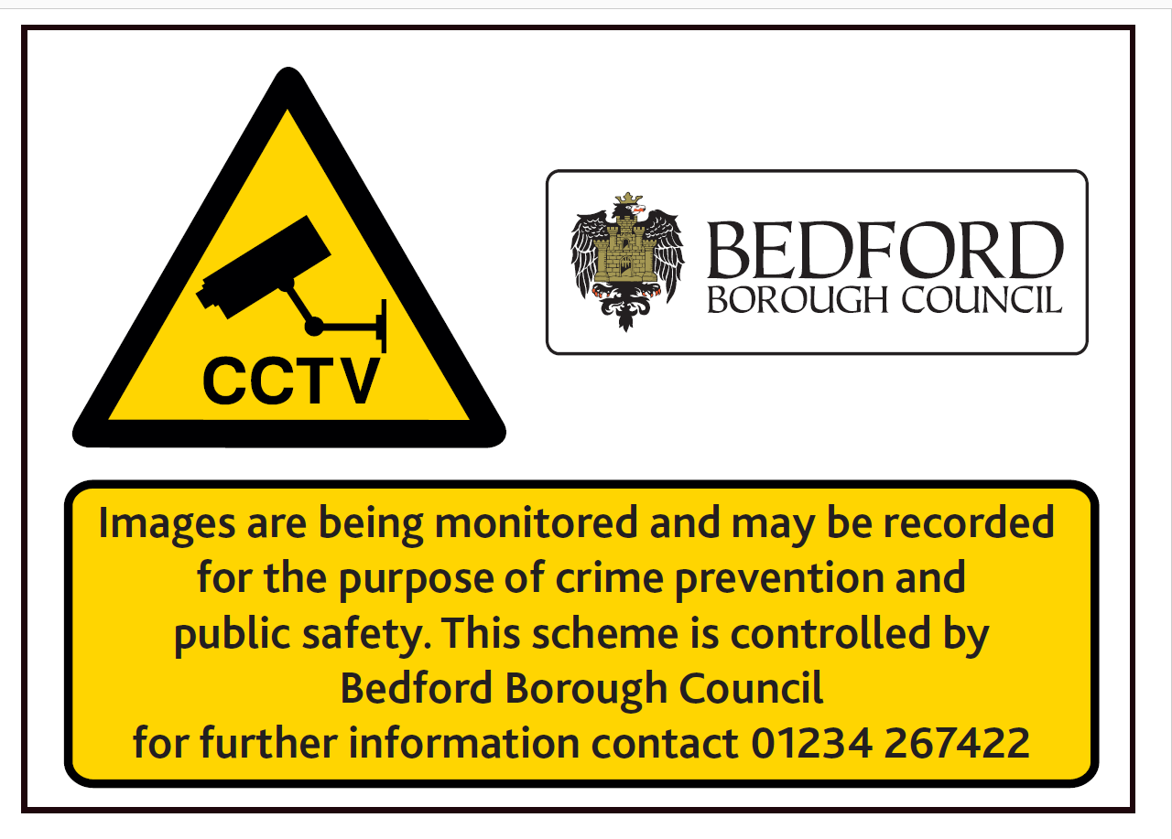

Annex B to CCTV Code of Practice
Dated 31 Mar 2018

B. List SOPs and Assignment Instructions

DOCUMENT
Control Room Operations Training Manual
Health & Safety Risk Assessment
Timegate booking on/off and check calls
Guidance Rest Break Documentation
Missing Check Call Procedure
Telephone Bomb Threat Procedures
Control Room Operations Training Manual
CCTV Operator Job Description
Radio Procedures
Shift Swap Approval Request
Holiday Form

Annex C to CCTV Code of Practice
Dated 31 Mar 2018

C. Relevant Acts, Regulations and COPs Governing
    - Human Rights Act
    - Protection of Freedoms Act
    - ICO Code of Practice
    - Camera Commissioners Code of Practice
    - Regulation of Investigatory Powers Act

 | Act | Purpose
 | This Code of Practice | Transparency to Public
 | ICO CCTV Code of Practice | Guidance as to use fo CCTV
 | Camera Commissioners COP | Guidance as to use fo CCTV
 | Regulation of Investigatory Powers Act | Guidance as to the use of Directed and covert surveillance
 | Protection of Freedoms Act | General Legislation on Freedom
 | Data Protection Act | General Legislation on Data Protection for personal data including CCTV images
 | General Data Protection Regulations | General Legislation on Data Protection for personal data including CCTV images from 25/5/18
 | Crime and Disorder Act | General Legislation giving guidance to measures that can be used to combat crime and disorder and partnership working
 | Human Rights Act | UK Enactments of Human Rights Act
 | Data Protection Bill/Act 2018

Annex D to CCTV Code of Practice
Dated 31 Mar 2018

D. Diagram of responsibilities

CEO (Data Controller)

Director for Environment

Cheif Officer for Regulatory Services & Culture

Community Safety & Resilience Manager
CCTV lead Officer
CCTV Contract Manager and CCTV Monitoring Team (Broadlands)

Annex E to CCTV Code of Practice
Dated 31 Mar 2018

E. Broadlands Company details


Broadland Guarding Services Ltd
Delta House
Vulcan Road North
Norwich
Norfolk
NR6 6AQ

Annex F to CCTV Code of Practice
Dated 31 Mar 2018

F. Information sharing agreements
Bedfordshire Police | CF/2010/09794

Annex G to CCTV Code of Practice
Dated 31 Mar 2018
G. Access List

 | Unrestricted Access
 | CEO  Director  Chief Officer  CCTV Lead Officer  CCTV Staff  Governance Inspectors (ICO, SIA) | Sign in at entrance
 | Access on Request
 | Police Staff  Council Officers  Partner Organizations Representatives  Third Party Business Partners  Fire Brigade Officers on duty | Request in writing, email or telephone appointment  Sign in at entrance
 | Members of Public for SAR  Members of Public for Public Relations  Any other person | Formal Request  Sign in at entrance

Annex H to CCTV Code of Practice
Dated 31 Mar 2018

H. Data Protection Legislation Subject Access Procedure (SAR)
1. Example of the SAR Procedure used by Bedford Borough Council
Individuals have the right to access their personal data. This is commonly referred to as subject access.

- Individuals can make a subject access request verbally or in writing.
- The Council will respond within one month.
- There is no fee chargeable unless the requests are unnecessarily repetitive or vexatious.
- The council does have the right to refuse to comply with a request but must be able to justify any such refusal evidentially.

Data Subject:

The person that the information is about

Who to contact: In writing or email

Customer Experience and Digital Systems
Riverside Building
Bedford Borough Council
Cauldwell Street
MK42 9AP

Email: Freedom.information@bedford.gov.uk

Telephone - Contact Centre 01234 276900

2. Requirements – Proof of Identification:

The reason we ask for proof of identification with CCTV is that it can be considered sensitive biometric information. Proof of identity will help to maintain the security of the information we hold about requestors and others and to ensure that we do not release your personal information to anybody else. Any documents submitted to us will be returned to the requestor. BBC CCTV will keep the level of identification requested proportionate to the sensitivity of the images. BBC CCTV will let the requestor know what to bring or send and where to deliver or send it.

Bedford Borough Council will not release information without proper authority, and reserves the right to request further proof of authority or identity if necessary.

Annex I to CCTV Code of Practice
Dated 31 Mar 2018

I. Third Party Sites

Company / Organisation Name
Bedford Pilgrims Housing Association
Kempston Town Council
Brickhill Parish Council Woodlands Park
Great Denham Parish Council
Riverside North
ACE Fire and Security SLA Schedule 1 Companies
Willington Parish Council

Bedford Borough Council
CCTV Code of Practice

Version V1/R1 Approved for use by:

Angela WILLIAMSON__________________________________________
Name In Full Date: 23/11/2020
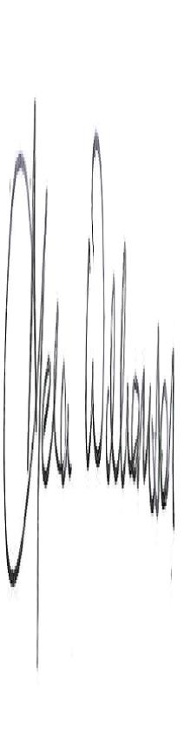
_________________________________________
Signature

