Neighbourhood Area Application
Decision Statement

Section 61G Town and Country Planning Act 1990
as inserted by the Localism Act 2011 Schedule 9 paragraph 2

An application for the designation of the parish of Ravensden as a Neighbourhood Area was received from Ravensden Parish Council 9 October 2019.

Bedford Borough Council considers that the application meets the requirements of the above legislation and therefore has designated the area shown on the attached map as ‘Ravensden Neighbourhood Area’.

Signed

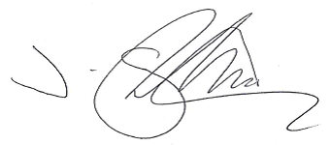

Jon Shortland
Chief Officer – Planning and Highways

Dated:
23 October 2019

