Neighbourhood Area Application
Decision Statement

Section 61G Town and Country Planning Act 1990
as inserted by the Localism Act 2011 Schedule 9 paragraph 2

An application for the designation of the parish of Odell as a Neighbourhood Area was received from Odell Parish Council on 16 August 2019.

Bedford Borough Council considers that the application meets the requirements of the above legislation and therefore has designated the area shown on the attached map as ‘Odell Neighbourhood Area’.

Signed

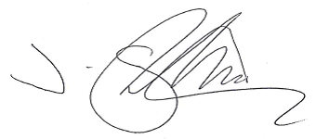

Jon Shortland
Chief Officer – Planning and Highways

Dated: 6 September 2019

