SCHOOL ADMISSIONS SERVICE |  | 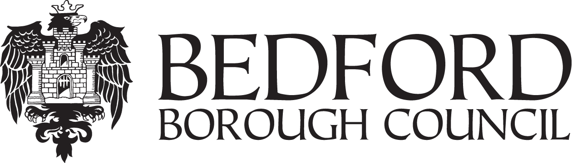
APPLICATION FOR CATHOLIC SCHOOLS ONLY
CONFIRMATION OF RELIGIOUS AFFILIATION

If you are applying for a place on religious grounds at the following Catholic schools because you are a practising Catholic family, your priest must confirm this, by signing a Certificate of Catholic Practice. This is a new requirement from the schools within the Our Lady Immaculate Catholic Academies Trust. The blank Certificate can be obtained from the schools or downloaded from our website, www.bedford.gov.uk/onlineadmissions

If you are applying because although you are not a practising family, your child has been baptised Catholic, or enrolled in a catechumenate programme, you must provide their Baptismal Certificate or your priest must confirm enrolment in the programme by signing the declaration below.

If you are applying because you a practising member of another religion or faith you must make sure that your priest, minister or faith leader completes the declaration below to support your application.

St John Rigby Primary | St Joseph’s and St Gregory’s Primary | St Thomas More Secondary

School (see list above)

Pupil’s Surname

Pupil’s First name

Date of Birth

Address

I attach a copy of my child’s baptismal certificate

Declaration by Priest, Minister or Faith Leader
I confirm that: Please Tick

This child is not baptised but is enrolled in a catechumenate programme

I support this application
Name and address of priest, minister or faith leader: Name of congregation/place of worship:

Christian denomination or religious faith: Signature of priest/minister/faith leader:

Date:

